# Idea

The theme of this story game is about the life cycle of the silkworm.

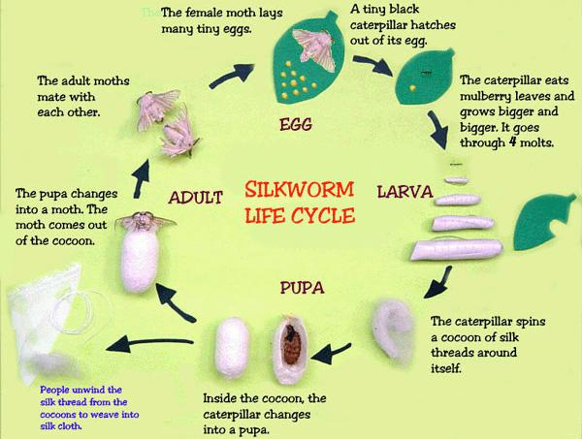

The total life cycle of a Silkworm ranges from 6-to 8 weeks. Generally, the warmer the weather, the quicker the Silkworm will complete its life cycle, however, other factors such as humidity and exposure to sunlight are also very important. Ideally, Silkworms will experience 12 hours of sunlight, and 12 hours of darkness per day, a temperature of 23-28 degrees Celsius, as well as humidity levels of 85-90%. Under these conditions, your eggs should hatch in 7-10 days.

## Eggs

In Australia, a Silkworm will naturally hatch in late July to early August – depending on the weather where you live – this time amazingly coincides with the Mulberry Tree regaining its leaves after the tree loses them in Winter. It is recommended that you store all of your eggs in a cold space (a fridge is ideal) because if there are fluctuations in the weather, your eggs may hatch earlier than expected. When placed in a cold area, we can control when our eggs hatch, therefore ensuring they will always have a food source. If our eggs have been placed in the fridge, they will begin developing and hatch after 10-25 days, depending on the warmth of the weather, with warmer weather causing quicker hatching.

## Larva/ Cocoon

After 20-33 days of constantly munching away at Mulberry leaves or chow, your Silkworm will feel the urge to cocoon. Lava that is ready to cocoon will be noticeable to the human eye, as they will appear translucent and yellowish. Just before it begins cocooning, the Silkworm will excrete a runny fluid to clean out its system and prepare it for the last stage of its life cycle. It will then ooze a tiny drop of Silk for anchoring, before going on to draw one long, continuous filament of Silk by swinging its head to-and-fro. This process can take up to 48 hours for the Silkworm to fully complete, and the result will be a perfectly ovate cocoon, with one continuous strand of silk up to 1 kilometer long! Inside the cocoon, the Silkworm will molt for the last time, as it approaches the last stage of its life cycle to become a moth. Sometimes Silkworms do funny things, and this is evident when a Silkworm decides to spin a cocoon with a friend. When this happens, the cocoon will be noticeably larger, however, if the two are members of the opposite sex, sometimes the cocoon does not hatch, and we will open it to find two dead Silk-Moths and a bunch of eggs inside the cocoon!

# Moth

After 10-14 days of developing into a moth in its cocoon, the Silk-Moth will appear from the cocoon and will excrete a brownish fluid upon emergence – don’t worry, this is completely normal, and is a sign the Silk Moth is cleaning out its system.

Silk-Moths cannot fly, as a result of thousands of years of domestication, however male Silk-Moths may leave their container/shoebox as they search for a female mate. Some males may be able to almost fly if you drop the from a small height, however it is uncontrolled, and they will hit the ground after a few moments.

It is quite easy to separate the male and female Silk-Moths, with the females having larger abdomens and males possessing smaller abdomens. Males also tend to be more active, as they are constantly searching for a mate. The moth lives a very brief life of 5-10 days, with males generally living longer than Females. Silk-Moths will begin to search for a mate almost immediately after emerging from their cocoon, with some seen mating with a moth of the opposite sex inside their cocoon should two moths share one! After mating, the Female Moth will lay between 300-500 eggs, and die, whereas the male Silk-Moth will search for another mate, should it not be too old.

<https://youtu.be/bvLghveYDIk>

<https://youtu.be/8DzGXGBhF-U>

## Game Story Part-1:

In native northern China, where lots of silk moth lives there was a male silk moth named Li Yun and a female silk moth Zhang Yi. Li Yun was travelling in the mulberry forest searching for food then he suddenly meets Zhang Yi. Her prettiness attracts him and then both of them fell in love with each other.

In early summer, Zhang Yi laid eggs (centrolecithal eggs) on mulberry leaves. She lays 300-500 eggs colored lemon yellow. The egg will go throw rain and wind and some of them even gets destroyed. 100 of eggs survived and after 7 to 20 days the egg got hatched and turned into grey color. Ni Yun and his siblings born form those eggs. Now, little Ni Yun is ready to go out and have fun in mulberry forest.

## Playing part 1:

A playable game world is created where Ni Yun in caterpillar form will be playable.

## Game Story Part-2

After eating some mulberry leaves, Ni Yun will see the sign board drawn by one of his own kind. He sees it and immediately remembers the flash back where one of an old caterpillar (Zhu Shin) giving his sibling and him lesson about making the sign board in case they get loss. Master Zhu Shin also told them to look for the lost caterpillar if they ever see that sign.

Ni Yun found his three siblings Ying Yun, Ming Yun and Xin Yun, and asked them to help that lost caterpillar but the told him its someone trying to prank. They made fun of him and tell him that he is too credulous and dumb that he couldn’t know that it’s prank. Ni Yun and his three siblings had argument over it and his siblings refused to go with him. Ni Yun told them he is not dumb and credulous, it’s just what if that caterpillar really needs help and what if something bad happened to that caterpillar if that caterpillar is not rescued. After hearing that his three siblings still made fun of him, laughed at him and told him to go alone if he wants to. Ni Yun said to them, “You will never know, if you don’t try” and went towards the direction of the board searching for the lost one.

## Playing Part 2

In this game Ni Yun have to doze the bird and fight the ant to reach to the destination

To jump to the other side Ni Yun have to roll on and hit the leaf to get spring jump to the other side

## Game Story Part 3

Ni Yun heard the sound of someone crying and he move towards that sound. He saw his sister Mei Yun crying. He went towards and said Hey Mei it’s all right, your brother is here now. He told her not to worry and comfort her. Mei Yun stopped crying. Ni Yun told her that he will show her way back to the mulberry forest and try to stick with him because its too dangerous out there. She thanked Ni Yun for coming to help her. Ni Yun told her that its brother duty to protect his sister and both of them went towards the mulberry forest.

### Playing Part 3

The gameplay of the part is same as part 2. Ni Yun will be infront of Mei Yun and Mei Yun will be following the Ni Yun. When the bird attack Ni Yun will use leaf as shield for him and his sister. Ni Yun will clear the path for Mei Yun in this game.

